Massage Intake Form

Name: Date:
Address: DOB: Email: Phone(Day:) (Night): Emergency Contact: Phone: Date of injury: Insurance ID: Insured: Self Spouse Other
Name of physician/source of referral: List symptoms: Please show on the diagrams where you feel your symptoms:

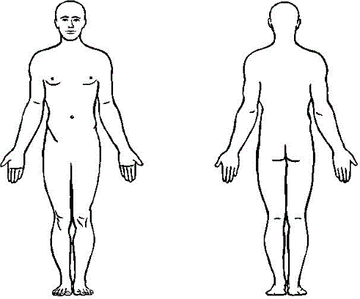

Does anything help to relieve your symptoms?

Does anything aggravate your symptoms? What do you do for exercise and how often?

Do you often feel stressed or anxious? If so, what do you do to release your stress and anxiety?

For the following, please put a “C” for current and/or a “P” for past if any of these conditions apply.
General: Headaches: Pain: Sleep disturbances: Fatigue: Infectious: Fever: Sinus: Skin Conditions: Rashes: Athlete’s foot, warts: Allergies: Scents, oils, lotions: Detergents: Other: Muscles and joints: Rheumatoid arthritis: Osteoarthritis: Osteoporosis: Scoliosis: Broken bones:
Spinal or disk problems: Lupus: TMJ, jaw pain: Spasms, cramps: Sprains, strains, tendonitis, bursitis: Joint problems: Neck, shoulder, arm, low back, hip, leg pain: Nervous System: Head Injuries: Dizziness, ringing in ears: Loss of memory: Numbness/tingling: Sciatica: Chronic pain: Depression: Other: Respiratory/cardiovascular: Heart disease, stroke, irregular heart
beat: Chest Pain: Blood clots: High/low blood pressure: Swelling, poor circulation, varicose veins: Asthma:
Digestive/Elimination System: Abdominal pain: Poor digestion: Poor elimination, irregular elimination: Other:
Endocrine System: Thyroid dysfunction: Diabetes: Reproductive System: Pregnancy: Painful, emotional menses: Fibrotic cysts: Other: Cancer/Tumors: Benign: Malignant:
Habits: Tobacco: Alcohol: Coffee/soda: Other:

Any further explanation for above information OR something else you think I should be aware of?

Contract for Care
I promise to participate fully in my health care, make choices that support my health and well-being, and let my practitioner know the effect of the treatments and exercises given.
I give my consent to receive treatment. I will inform my practitioner if I feel compromised or unsafe at any time.
I have provided all the information about my health history in good faith and will inform my practitioner of any changes.

Signature: Date:

